Intelliware 1.0 setup
Assignment 2

For the Intelliware 1.0 software package we came up with this design:
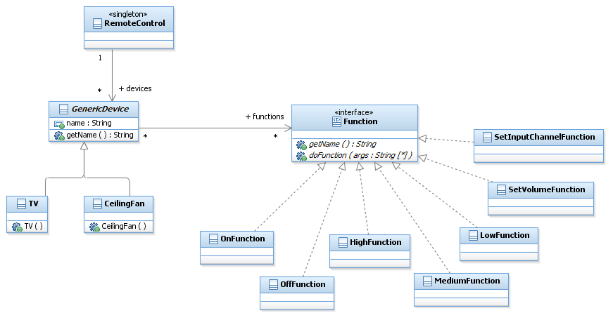
This means we have specific devices such as a CeilingFan or TV inheriting from a GenericDevice class. The GenericDevice class has an ArrayList with the interface class-type GenericFunction which is then filled with specific implementations of functions. The amount and type of functions are determined by the specific device classes.
There are also specific Function classes such as: On/Off, Notify, SetVolume etc.
The specific Function classes implement a Function interface, so that every functionclass has one specific method: doFunction(). This method allows a class to do what it is supposed to do. For example: turning on/off a device, setting the volume, changing the channel etc.
The method doFunction receives an undetermined number of parameters. Some functions will not use any (such as OnFunction and OffFunction), whereas others will need one or more parameters (such as SetVolumeFunction, which needs one parameter to set a particular volume).
With this design, which you could call a modular set up. It is easy to add new specific devices, supply them with existing functions or add new functions for the device and other new or existing devices to perform.
In this design, the Strategy pattern is easily found. It is used to add behavior (i.e. functions) to every device in a dynamic way.

Code Snippets – IntelliWare 1.0

public class GenericDevice {
protected String name;
protected ArrayList<Function> functions = new ArrayList<Function>();

public String getName() {
return name;
}

public boolean doFunction(String function, String[] args) {
// loop through device functions to find desired function
for (int i = 0; i < functions.size(); i++) {
// verify if we have match
if (functions.get(i).getName().equals(function)) { // execute function and display function success
Any functions can be passsed to any device however the Generic Device class will always filter out those requests that a device can't handle. The success or failure of a function will be returned.
if (functions.get(i).doFunction(args)) {
// print what executed function
System.out.println("function '" + function +
"' peformed by " + name);
} else {
System.out.println("function '" + function +
"' can not be executed by " + name +
" (requires different arguments)");
}
// return we executed command
return true;
}
}
// function not found, not supported by device, print message
System.out.println("function '" + function + "' not supported by " + name);

// return false
return false;
}
}
You can create new devices and send commands directly to them. You can simulate any command being send to the device and the device class will filter out the invalid commands.

TV myTV = new TV();
myTV.doFunction(
"ON",new String[]{""});
myTV.doFunction(
"SET_VOLUME", new String[]{"20"});

public interface Function {
public String getName();
public boolean doFunction(String[] args);
}

public class TV extends GenericDevice {
public TV() {
name = "TV";
functions.add(new OnFunction());
functions.add(new OffFunction());
functions.add(new SetInputChannelFunction());
functions.add(new SetVolumeFunction());
}
}

You could also manipulate multiple devices by using a Generic Device arraylist and a simple for each loop as illustrated below.

oaAllDevices.add(myFan);
oaAllDevices.add(myAlarm);
oaAllDevices.add(myTV);
for (GenericDevice device : oaAllDevices) {
device.doFunction(
"OFF", new String[]{""});
}
public class OnFunction implements Function {

@Override
public String getName() {
return "ON";
}

@Override
public boolean doFunction(String[] args) {
System.out.println("Turn On");
return true;
}
}

